CREATION OF DATABASE

1. Start Apache and MySQL
- Opened XAMPP control panel.
- Clicked "Start" for Apache and MySQL.
2. Open phpMyAdmin
- In our browser, went to: http://localhost/phpmyadmin
3. Create Database
- Clicked "New" on the left side.
- Created a database name by SQL language (online_fashion_store_management_system).

CREATE DATABASE online_fashion_store_management_system;
4. Create Table
- We went Inside our database using SQL language.

USE online_fashion_store_management_system;
- Added Tables with fields (columns)
- CUSTOMER Table

CREATE TABLE CUSTOMER(
Id INT(15) AUTO_INCREMENT,
Name VARCHAR(100) NOT NULL,
Email VARCHAR(100) NOT NULL,
Password VARCHAR(10) NOT NULL,
PRIMARY KEY (Id),
UNIQUE (Email)
);

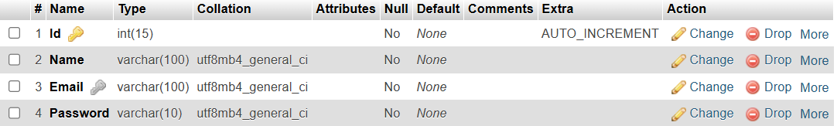
- ADMIN Table

CREATE TABLE ADMIN(

Id INT(15) AUTO_INCREMENT,
Name VARCHAR(100) NOT NULL,
Email VARCHAR(100) NOT NULL,
Password VARCHAR(10) NOT NULL,
PRIMARY KEY (Id),
UNIQUE (Email)
);

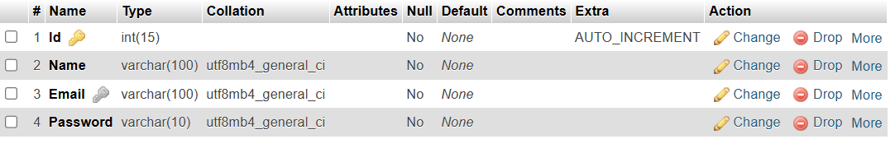

- PRODUCT Table

CREATE TABLE PRODUCT(
Id INT(15) AUTO_INCREMENT,
Name VARCHAR(100) NOT NULL,
Price DOUBLE(8,2) NOT NULL,
Category VARCHAR(50) ,
Image MEDIUMBLOB ,
Stock INT(6) DEFAULT 0,
Product_detail TEXT NOT NULL,
Status VARCHAR(50) NOT NULL,
Admin_id INT(15),
PRIMARY KEY (Id),
FOREIGN KEY (Admin_id) REFERENCES ADMIN (Id) ON DELETE SET NULL ON UPDATE CASCADE
);

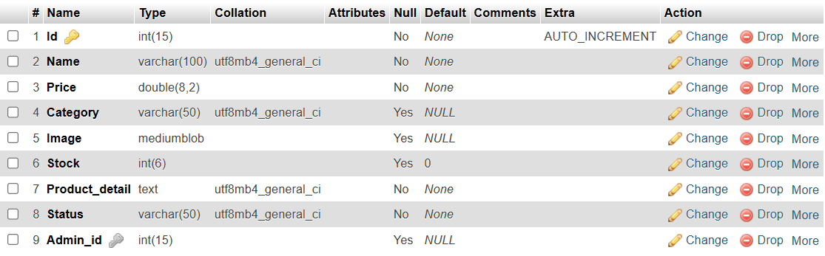
- CART Table

CREATE TABLE CART(
Id INT(15) AUTO_INCREMENT,
Customer_id INT(15),
PRIMARY KEY (Id),
FOREIGN KEY (Customer_id) REFERENCES CUSTOMER (Id) ON DELETE SET NULL ON UPDATE CASCADE
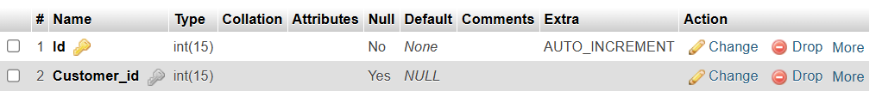
);

- CART_PRODUCT Table

CREATE TABLE CART_PRODUCT(
Cart_id INT(15) ,
Product_id INT(15),
Quantity INT(6) DEFAULT 0 ,
PRIMARY KEY (Cart_id, Product_id),
FOREIGN KEY (Cart_id) REFERENCES CART (Id) ON DELETE CASCADE ON UPDATE CASCADE,
FOREIGN KEY (Product_id) REFERENCES PRODUCT (Id) ON DELETE CASCADE ON UPDATE CASCADE
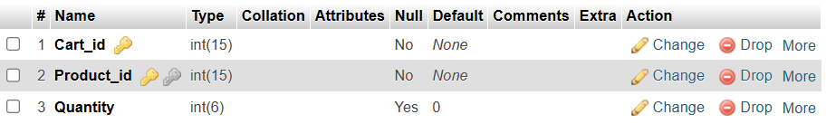
);
- WISHLIST Table

CREATE TABLE WISHLIST(
Id INT(15) AUTO_INCREMENT,
Customer_Id INT(15),
PRIMARY KEY (Id),
FOREIGN KEY (Customer_Id) REFERENCES CUSTOMER (Id) ON DELETE SET NULL ON UPDATE CASCADE
);
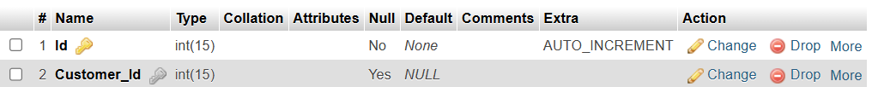

- WISHLIST_PRODUCT Table

CREATE TABLE WISHLIST_PRODUCT(
Wishlist_id INT(15),
Product_id INT(15),
PRIMARY KEY (Wishlist_id, Product_id),
FOREIGN KEY (Wishlist_id ) REFERENCES WISHLIST (Id) ON DELETE CASCADE ON UPDATE CASCADE,
FOREIGN KEY (Product_id) REFERENCES PRODUCT (Id) ON DELETE CASCADE ON UPDATE CASCADE
);
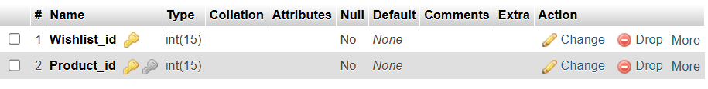

- MESSAGE Table
CREATE TABLE MESSAGE(

Id INT(15) AUTO_INCREMENT,
Customer_id INT(15),
Message_type VARCHAR(9) NOT NULL,
Message TEXT NOT NULL,
PRIMARY KEY (Id),
FOREIGN KEY (Customer_id) REFERENCES CUSTOMER (Id) ON DELETE SET NULL ON UPDATE CASCADE
);

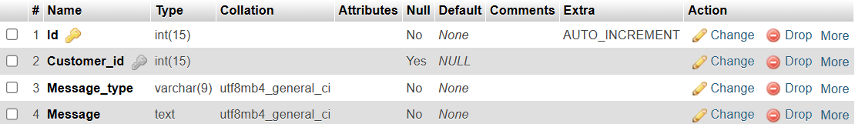

- ORDER_TABLE Table

CREATE TABLE ORDER_TABLE(
Id INT(15) AUTO_INCREMENT,
Phone_number VARCHAR(15) NOT NULL,
Address VARCHAR(100) NOT NULL,
Address_type VARCHAR(7) NOT NULL,
Payment_method VARCHAR(20) NOT NULL,
Ordered_date DATE NOT NULL ,
Ordered_time TIME NOT NULL ,
Payment_status VARCHAR(50) NOT NULL,
Status VARCHAR(50) NOT NULL,
Cart_id INT(15),
PRIMARY KEY (Id),
FOREIGN KEY (Cart_id) REFERENCES CART (Id) ON DELETE SET NULL ON UPDATE CASCADE
);
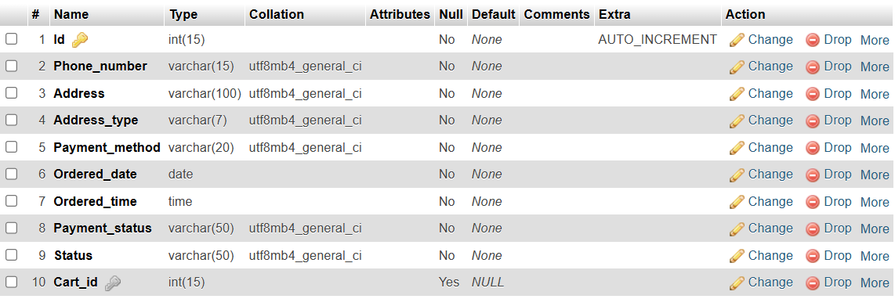
- DELIVERY Table

CREATE TABLE DELIVERY(
Id INT(10) AUTO_INCREMENT,
Order_id INT(15),
Delivery_status VARCHAR(50) NOT NULL,
PRIMARY KEY (Id), FOREIGN KEY (Order_id) REFERENCES ORDER_TABLE (Id) ON DELETE SET NULL ON UPDATE CASCADE
);
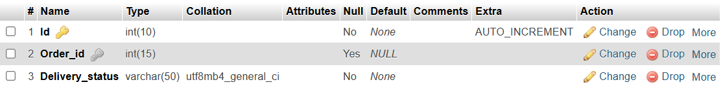

Assumption

- Address_type of ORDER_TABLE should be only Home or Office.
- Payment_method of ORDER_TABLE should be only Cash or Card Payment .
- Message_type of MESSAGE should be only complaint or normal.
- ALL TABLES
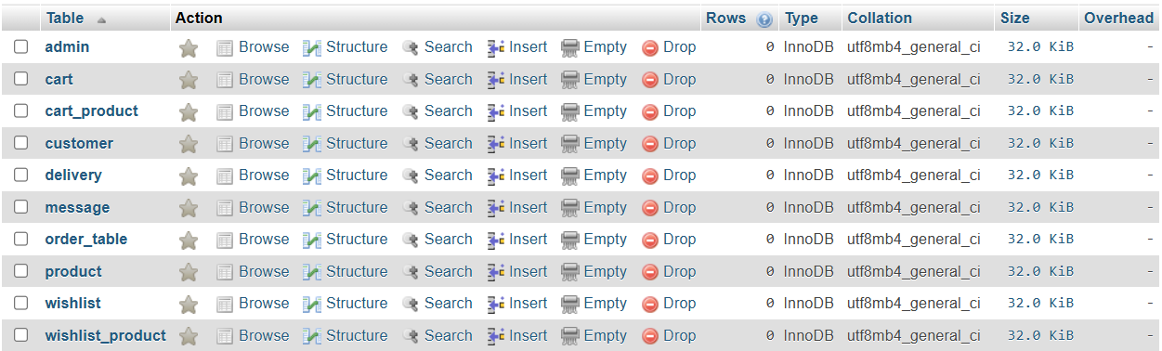
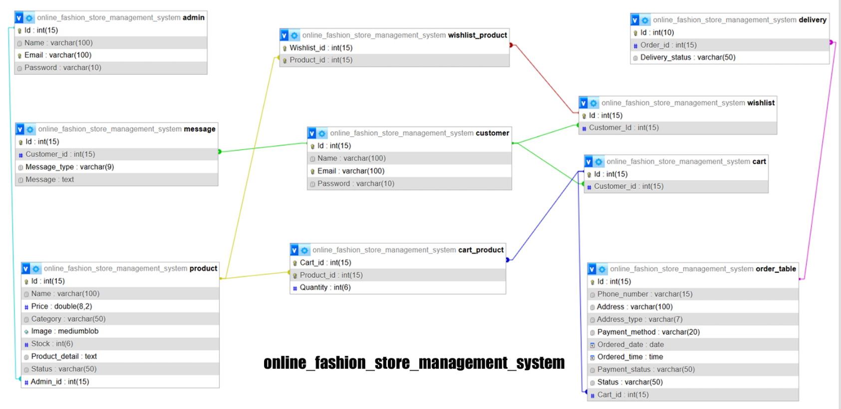
- TABLE DESIGN AND CONNECTIONS

TESTING PHASE

ADDING DUMMY DATA
- For customer table
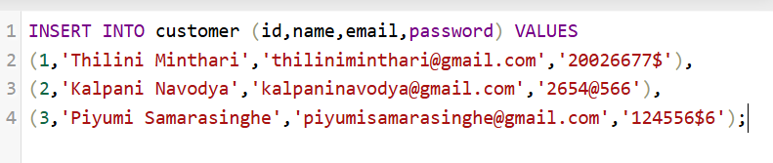
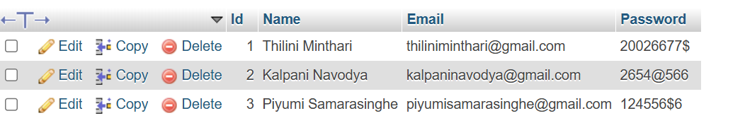
- For admin table
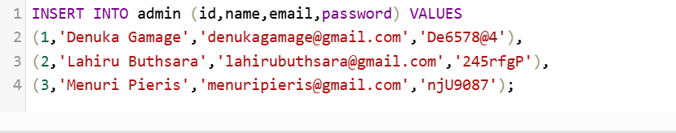
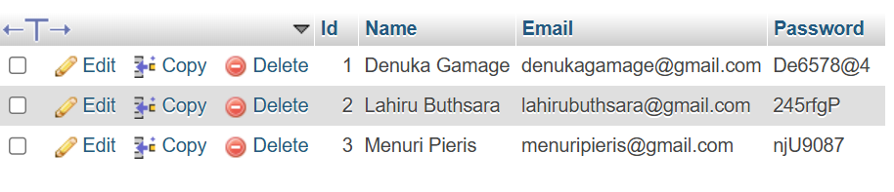

- For product table
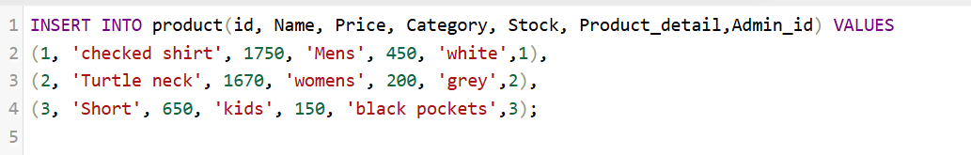
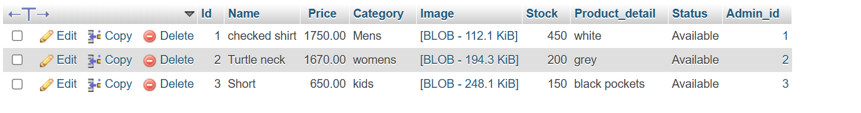
- For cart table
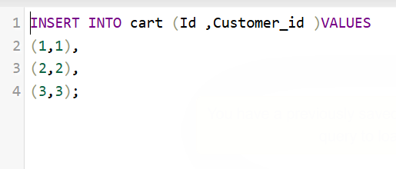
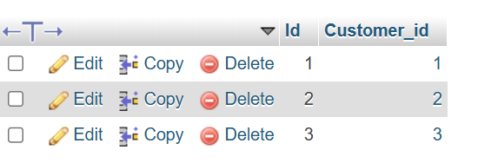

- For cart_product table

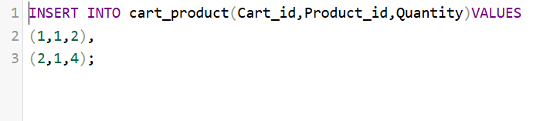
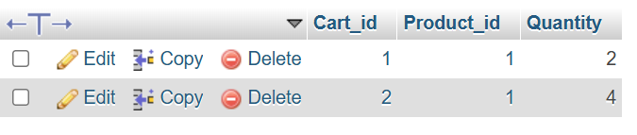
- For wishlist table

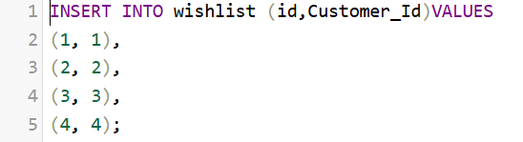
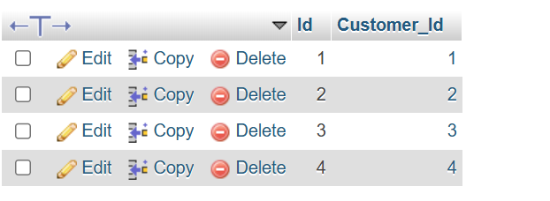

- For wishlist_product table
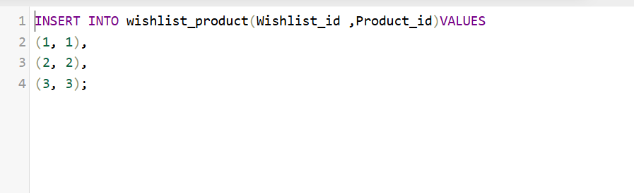
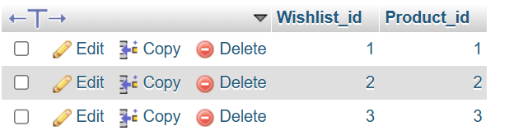
- For Message table
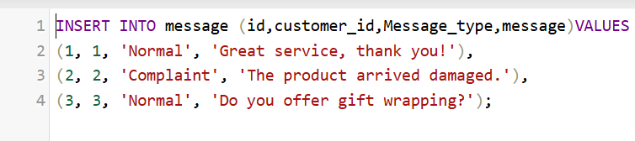
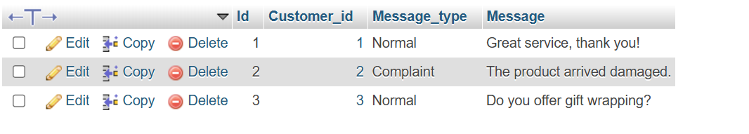

- For order_table table
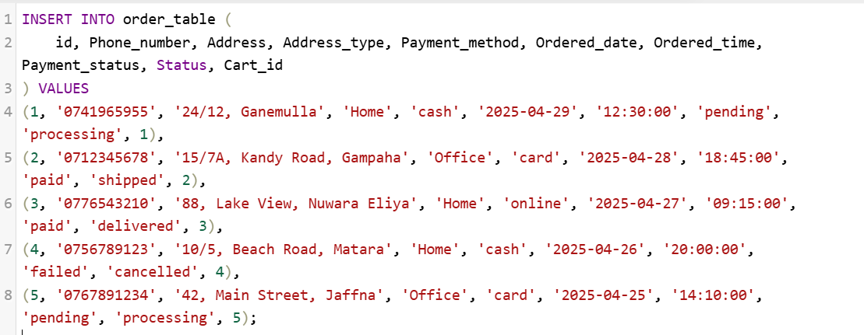
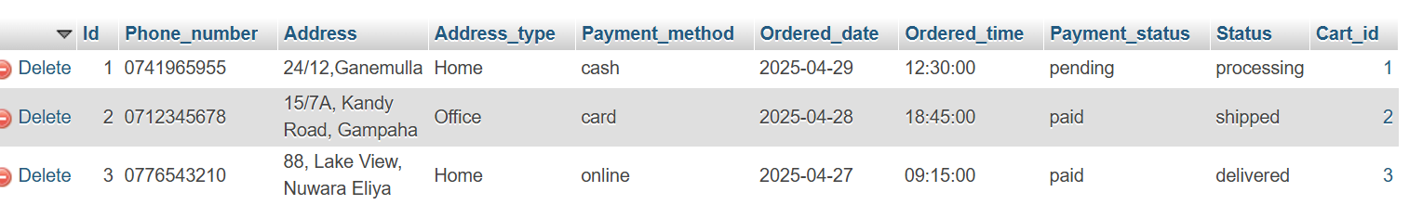
- For delivery table
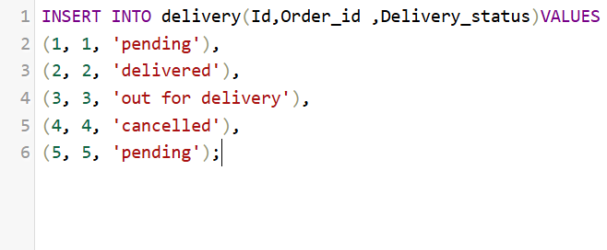
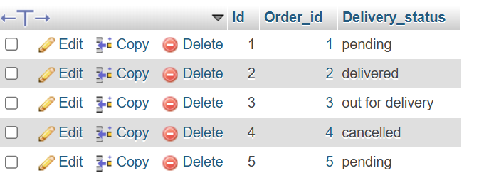

ALTERING DATA IN THE TABLES USING QUERIES
- Deleting an admin from the Admin table
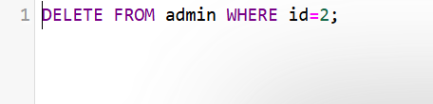
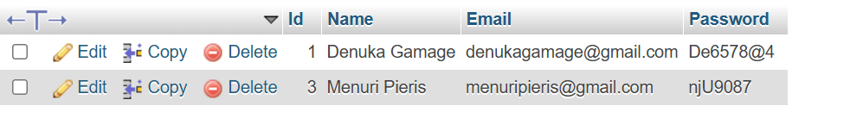
A record was deleted from the admin table, potentially affecting related entries in the product table.
Product table
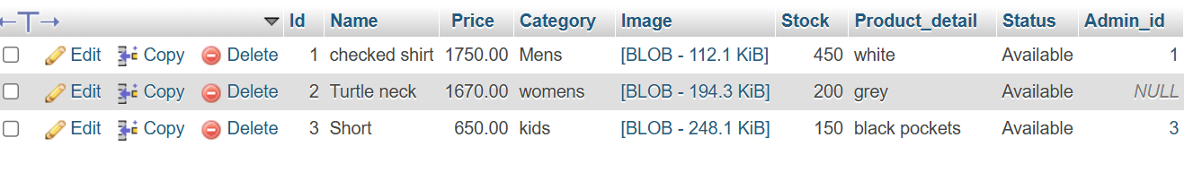
- Deleting a customer from the customer Table.
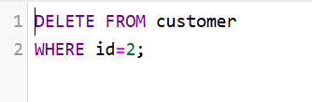
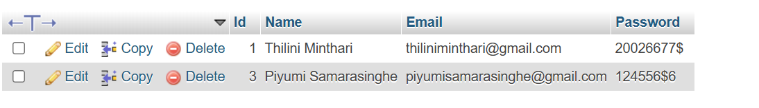
A record was deleted from the customer table, potentially affecting related entries in the cart, wishlist and message tables.
Cart table
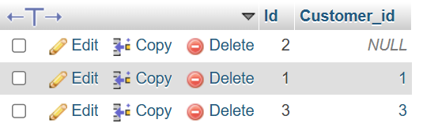
wishlist table
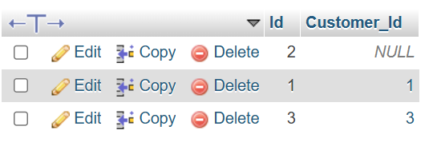
message table
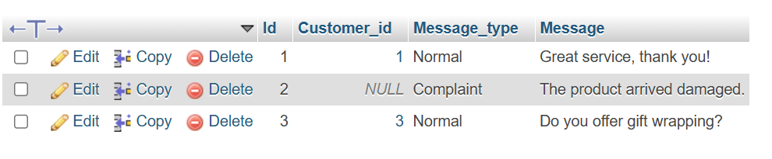
• Update the email of a customer in the database.
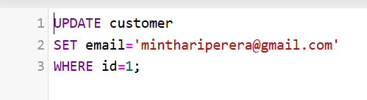

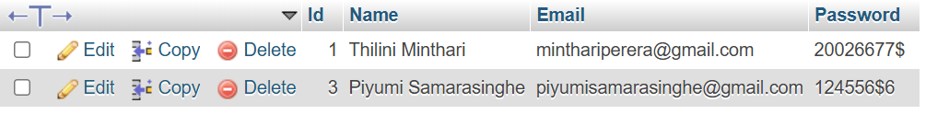
• Select Phone_number,Address,Ordered_date,Ordered_time,Delivery_status from the ordered_table and delivery tables.
